MultiChamber
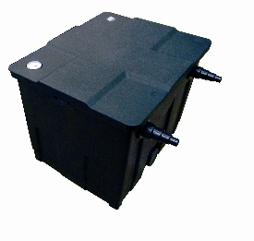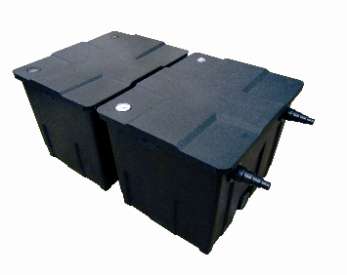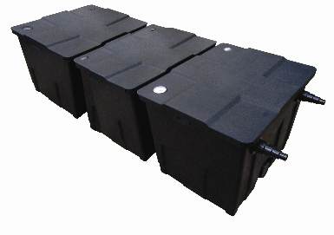

UV Biological Pond Box Filter

Model | Bay  Nos | Dimensions  LxWxD (mm) | Max.  Flow | Inlet Size  mm | Outlet Size | Rec.  Pump | Rec.  UVC
PXCF09000 | 1 | 535x465x405 | 8000lph | 20/25/32/40 | 70mm | PXFP46000 | 18w
PXCF18000 | 2 | 900x540x405 | 12000lph | 20/25/32/40 | 70mm | PXFP10000 | 24w
PXCF36000 | 3 | 1335x540x405 | 12000lph | 20/25/32/40 | 70mm | PXFP15000 | 36w

Introduction
Congratulations on the purchase of your pondXpert filter. Once your filter is connected you can look forward to many years of healthy pond water.

Your filter works by connecting it to a solids-handling filter via the stepped hosetail inlet via pondhose. The water flow then passes through the filter’s chambers and finally back out into the pond via the water outlet.

PondXpert filters are carefully inspected and tested to ensure both safety and operating performance. However, failure to follow the instructions and warnings in the manual may result in product damage and/or serious injury. Be sure to read and save this manual for future reference.

Features
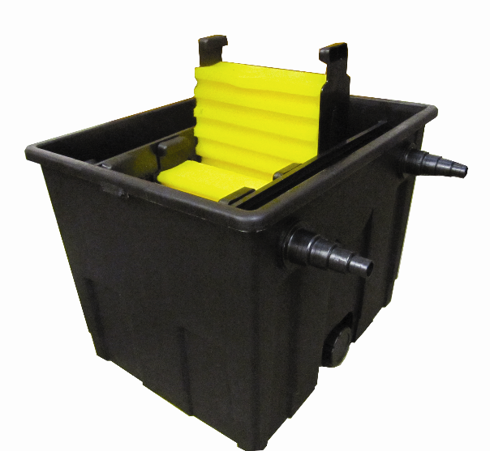
EasyClean Sponges
Filter sponges simply lift out by the handles the squeeze out dirt by using the grips as shown
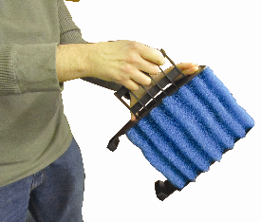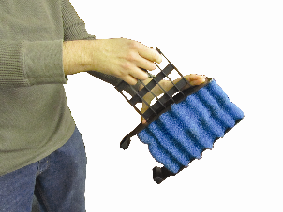

General safety Instructions
Read and observe all of the instructions before installing, connecting and operating.
Make sure the filter is securely and correctly installed before switching on.
Always disconnect the UV when not in use and when carrying out maintenance.
Always disconnect all equipment in the pond before starting to handle, maintain, repair or install any pond equipment.
The appliance is not intended for use by persons (including children) with reduced physical, sensory or mental capabilities, or lack of experience and knowledge, unless they have been given supervision or instruction concerning use of the appliance by a person responsible for their safety.
Children should be supervised to ensure that they do not play with the appliance.
For safety reasons, servicing or repair of this item should only be carried out by pondXpert.
Never hang or carry the pump by the power cord.
Do not operate the pump with a damaged cord or plug. The supply cord of the appliance cannot be replaced.

If the electrical cord is damaged the product should be scrapped.

Safety and Electrical Connections
This unit is designed for outdoor use only. It is weatherproof and should be situated safely pondside. The filter should be sited where it cannot fall into the water or become waterlogged.
NO PART OF THIS UNIT SHOULD EVER BE SUBMERGED IN WATER.
Direct exposure to UVC light can damage the eyes and skin. NEVER look directly at the UV when switched on. The translucent inlet will illuminate showing that the UV is working.
Always disconnect all equipment in the pond before starting to handle, maintain, repair or install any pond equipment.

The ultra violet clarifier housed within the pondXpert box filter is electrically operated so great care must be taken during installation and operation. The following electrical and safety guidelines must be carefully followed.

Each filter is supplied with a length of 3 core electrical cable which is permanently connected to the ultra violet clarifier unit housed inside the filter.
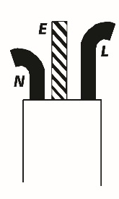
1st January 2005 revised Building Regulations for England and Wales
Installing this product in the garden is classified as ‘notifiable’. The Regulations now require you to tell your local authority building control department that you intend to install this product before installation. Your local authority will let you know how you can get your installation approved
The wires in the mains electrical lead are coloured in accordance with the
following code:
BLUE – Neutral (marked with an “N” in most terminal connections)
BROWN – LIVE (marked with an “L” in most terminal connections)
GREEN/YELLOW – EARTH (marked “E” or in most terminal connections)

The termination to the mains supply should be permanent, inside a dry weatherproof enclosure, through a double pole switched fused spur with a minimum contact gap of 3mm – (disconnected) to BS 3676 – and fitted with a 3 or 5 amp fuse.
Exposed cable runs should be sensibly positioned, and protected if necessary by armoured conduit.
A 10mA or 30mA Residual Current Circuit Breaker (RCD) MUST be fitted to the mains supply.
Permanent installations to the mains supply (hard wiring) must comply with the regulations of the local electricity authority which may stipulate the use of metal or plastic conduit to protect the cable.
If in any doubt about wiring to the mains supply contact a qualified electrician or your local electricity authority.
Protect from frost. In cold winter weather (when fish are inactive and algae growth ceases) the unit may be switched off. It should then be drained of water, removed (if possible) from its installation and stored in a dry, frost-protected area.
The supply cable cannot be replaced. If the cable is damaged, the unit must be discarded.

Directions for use

Installation
Once installed and connected to a suitable pump the pond water will flow through the filter.
PondXpert box filters are pump-fed, external filters with an integral UVC unit, ideal for being partially buried adjacent to your pond or being positioned above ground if desired. The filter may also be concealed at the top of a waterfall.
Your filter is supplied with a translucent hosetail. This should be screwed into the threaded filter inlet. Pond hose size 20-40mm (3/4” to 11/2”) can be attached to the inlet hosetail. Your pump and filter outlet should be positioned at opposite ends of the pond to promote maximum circulation.
Cut the inlet hose to the size appropriate to the size of hose you are using. Then connect the hose from your pump to this inlet hosetail and secure with hose clips.

Maturation of the Filter
Your multi-chamber box filter comes complete with mechanical and biological filter media. The filter foam acts as a mechanical barrier to pick up solids whilst the plastic bio-media helps to develop ‘friendly’ bacteria. These friendly nitrifying bacteria help to convert harmful fish waste and other organic waste (ie, ammonia, nitrite) into harmless nitrate. This ‘biological maturation’ process usually takes 6-8 weeks. It is recommended that you do not switch on your UVC during this period.

Maintenance
As the filter does it’s job the foam filters will block up reducing water flow. If the pond is very dirty then the foams may need cleaning every couple of days or so at first.
Cleaning procedure:
Switch off any electrical items feeding or inside the pond (including the filter itself).
Take the foam filters out of the unit and carefully wash away any solids using a bucket of POND WATER. Once clean replace the foams back in position.
If your filter is ever taken away from the pond (ie-winter storage) then all of the filter media (foams and biomedia) must be thoroughly cleaned before restarting. Your filter will then need to undergo the ‘maturation’ procedure phase as described above.

Filtration Spares and consumables
The filter is supplied with everything you need to get started (including filter media, UV bulb and quartz tube for the UV). Over time these parts may need replacing and can be purchased from your retailer. The multi-chamber design of the unit means you are free to test other media types (Japanese matting, Alfagrog etc) should you desire.

Bottom Drain Plug
Your pondXpert filter comes complete with an integral drain. To periodically drain the sludge from the base of the filter simply unscrew the drain cap. This drain point can also be used to backflush out debris if required.

Periods of operation
Maintain filtration 24 hrs a day through the fish feeding season (typically early March-October when the water temperature is above 10 degrees C), but preferably all year round. In the winter operating the pump and filter will maintain a background level of friendly bacteria in the filter and help prevent the pond icing up in all but the severest weather conditions.

Changing the UV Bulb
The UV bulb should be changed at the beginning of every new season. The lamp may look like it is working but the levels of effective UV radiation decrease over time.
Disconnect the unit from the electricity supply.
Push open the top access chamber to the UV. Remove the UV Clarifier unit by gently pulling the retaining clips. Unscrew the wired end-cap by rotating anti-clockwise.
Remove the UV bulb by gently pulling out of the electrical connection.
Insert a new UV bulb by gently pushing into the electrical connection.
Re-assemble the end cap by rotating clockwise.
Clip the UV unit back into the top housing and reposition the top lid in place.

Limited Warranty
This product is guaranteed for a period of 12 months from the date of purchase for material or manufacturing defects. The guarantee covers the substitution of defective parts. However, the guarantee is considered null and void in the case of improper use, improper handling or negligence on the part of the buyer. The UV lamp is not guaranteed. If your pondXpert filter fails please take it back to the retail outlet from where it was purchased. You will be required to take your receipt/proof of purchase with you. This does not affect your statutory rights.

PondXpert
A3 Bentley Avenue
Billingham
TS23 4BU
UK
Your appliance contains valuable materials which can be recovered or recycled. Leave it at a local civic waste collection point.

01642 370898

www.pondxpert.co.uk

